Bahria University,

Karachi Campus



LAB EXPERIMENT NO.

___01____

LIST OF TASKS

|  |  |
| --- | --- |
| TASK NO | OBJECTIVE |
| 01 | ***Make a five page website, including home page, linked altogether having header and footer section mandatorily. Web pages should cover all the html tags overall example make a gallery page with the help of table tag and insert images in that.*** |

Submitted On:

Date:25/03/2022

TASK:

***Make a five page website, including home page, linked altogether having header and footer section mandatorily. Web pages should cover all the html tags overall example make a gallery page with the help of table tag and insert images in that.***

WEB HOME PAGE

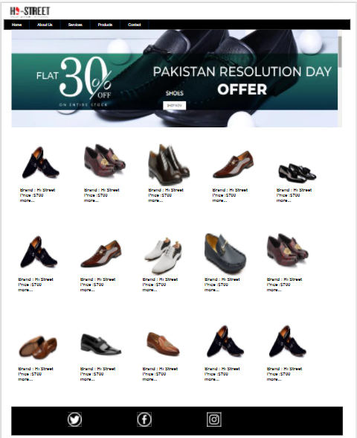

SOURCE CODE:

<!DOCTYPE html>

<html lang="en">

<head>

    <title>www.HiStreet.com</title>

    <link rel="stylesheet" href="web.css">

</head>

<body>

    <div style="width: 99%; height: 50px;background-color:white">

        <div style=" width: 150px;height: 50px; float: left; margin-top: 0px; margin-left: 20px;">

        <img src="C:\Users\HP ELITEBOOK 840 G3\Desktop\web_engineering\image3.png" alt="" style="border: 0px solid white; width:150px; height: 50px;">

        </div>

</div>

    <div style="border: 1px solid black ; width: 99% ; height: 35px;">

        <ul>

            <li class="active"><a href="a">Home</a></li>

            <li><a href="a">About Us</li>

            <li><a href="a">Services</li>

            <li><a href="a">Products</li>

            <li><a href="a">Contact</li>

            </ul>

    </div>

    <div style=" width: 99%; height: 350px;">

        <img src="C:\Users\HP ELITEBOOK 840 G3\Desktop\web_engineering\WhatsApp Image 2022-03-19 at 10.45.25 AM.jpeg" alt="" style="border: 0px solid white; width:100%; height: 350px;">

</div>

<div style="width: 99%; height: 1000px;background-color:white;">

    <div style="  width: 200px; height: 200px; margin-top: 40px;margin-left: 30px; float: left;color: black;padding-top: 20px;float: left;font-family: Arial, Helvetica, sans-serif;">

<img src="C:\Users\HP ELITEBOOK 840 G3\Desktop\web_engineering\pic7.jfif" style="height: 150px;width: 150px;"><br><b>Brand : Hi Street<br>Price :$700<br>more...</b>

    </div>

<div style=" width: 200px; height: 200px; margin-top: 40px;margin-left: 30px; float: left;color: black;padding-top: 20px;float: left;font-family: Arial, Helvetica, sans-serif;">

    <img src="C:\Users\HP ELITEBOOK 840 G3\Desktop\web_engineering\pic11.jpg" style="height: 150px;width: 150px; color: black;"><br><b>Brand : Hi Street<br>Price :$700<br>more...</b>

</div>

<div style=" width: 200px; height: 200px; margin-top: 40px;margin-left: 30px; float: left;color: black;padding-top: 20px;float: left;font-family: Arial, Helvetica, sans-serif;">

    <img src="C:\Users\HP ELITEBOOK 840 G3\Desktop\web_engineering\pic3.jfif" style="height: 150px;width: 150px;"><br><b>Brand : Hi Street<br>Price :$700<br>more...</b>

</div>

<div style="width: 200px; height: 200px; margin-top: 40px;margin-left: 30px; float: left;color: black;padding-top: 20px;float: left;font-family: Arial, Helvetica, sans-serif;">

    <img src="C:\Users\HP ELITEBOOK 840 G3\Desktop\web_engineering\pic8.jpeg" style="height: 150px;width: 150px;"><br><b>Brand : Hi Street<br>Price :$700<br>more...</b>

</div>

<div style=" width: 200px; height: 200px; margin-top: 40px;margin-left: 30px; float: left;color: black;padding-top: 20px;float: left;font-family: Arial, Helvetica, sans-serif;">

    <img src="C:\Users\HP ELITEBOOK 840 G3\Desktop\web_engineering\pic5.jfif" style="height: 150px;width: 150px;"><br><b>Brand : Hi Street<br>Price :$700<br>more...</b>

</div>

<div style=" width: 200px; height: 200px; margin-top: 100px;margin-left: 23px; float: left;color: black;padding-top: 20px;float: left;font-family: Arial, Helvetica, sans-serif;">

    <img src="C:\Users\HP ELITEBOOK 840 G3\Desktop\web_engineering\pic7.jfif" style="height: 150px;width: 150px;"><br><b>Brand : Hi Street<br>Price :$700<br>more...</b>

</div>

<div style=" width: 200px; height: 200px; margin-top: 100px;margin-left: 23px; float: left;color: black;padding-top: 20px;float: left;font-family: Arial, Helvetica, sans-serif;">

    <img src="C:\Users\HP ELITEBOOK 840 G3\Desktop\web_engineering\pic8.jpeg" style="height: 150px;width: 150px;"><br><b>Brand : Hi Street<br>Price :$700<br>more...</b>

</div>

<div style=" width: 200px; height: 200px; margin-top: 100px;margin-left: 23px; float: left;color: black;padding-top: 20px;float: left;font-family: Arial, Helvetica, sans-serif;">

    <img src="C:\Users\HP ELITEBOOK 840 G3\Desktop\web_engineering\pic9.jpg" style="height: 150px;width: 150px;"><br><b>Brand : Hi Street<br>Price :$700<br>more...</b>

</div>

<div style=" width: 200px; height: 200px; margin-top: 100px;margin-left: 23px; float: left;color: black;padding-top: 20px;float: left;font-family: Arial, Helvetica, sans-serif;">

    <img src="C:\Users\HP ELITEBOOK 840 G3\Desktop\web_engineering\pic10.jfif" style="height: 150px;width: 150px;"><br><b>Brand : Hi Street<br>Price :$700<br>more...</b>

</div>

<div style=" width: 200px; height: 200px; margin-top: 100px;margin-left: 23px; float: left;color: black;padding-top: 20px;float: left;font-family: Arial, Helvetica, sans-serif;">

    <img src="C:\Users\HP ELITEBOOK 840 G3\Desktop\web_engineering\pic11.jpg" style="height: 150px;width: 150px;"><br><b>Brand : Hi Street<br>Price :$700<br>more...</b>

</div>

<div style=" width: 200px; height: 200px; margin-top: 100px;margin-left: 23px; float: left;color: black;padding-top: 20px;float: left;font-family: Arial, Helvetica, sans-serif;">

    <img src="C:\Users\HP ELITEBOOK 840 G3\Desktop\web_engineering\pic12.jpg" style="height: 150px;width: 150px;"><br><b>Brand : Hi Street<br>Price :$700<br>more...</b>

</div>

<div style="width: 200px; height: 200px; margin-top: 100px;margin-left: 23px; float: left;color: black;padding-top: 20px;float: left;font-family: Arial, Helvetica, sans-serif;">

    <img src="C:\Users\HP ELITEBOOK 840 G3\Desktop\web_engineering\pic13.jfif" style="height: 150px;width: 150px;"><br><b>Brand : Hi Street<br>Price :$700<br>more...</b>

</div>

<div style=" width: 200px; height: 200px; margin-top: 100px;margin-left: 23px; float: left;color: black;padding-top: 20px;float: left;font-family: Arial, Helvetica, sans-serif;">

    <img src="C:\Users\HP ELITEBOOK 840 G3\Desktop\web_engineering\pic15.webp" style="height: 150px;width: 150px;"><br><b>Brand : Hi Street<br>Price :$700<br>more...</b>

</div>

<div style=" width: 200px; height: 200px; margin-top: 100px;margin-left: 23px; float: left;color: black;padding-top: 20px;float: left;font-family: Arial, Helvetica, sans-serif;">

    <img src="C:\Users\HP ELITEBOOK 840 G3\Desktop\web_engineering\pic7.jfif" style="height: 150px;width: 150px;"><br><b>Brand : Hi Street<br>Price :$700<br>more...</b>

</div>

<div style=" width: 200px; height: 200px; margin-top: 100px;margin-left: 23px; float: left;color: black;padding-top: 20px;float: left;font-family: Arial, Helvetica, sans-serif;">

    <img src="C:\Users\HP ELITEBOOK 840 G3\Desktop\web_engineering\pic7.jfif" style="height: 150px;width: 150px;"><br><b>Brand : Hi Street<br>Price :$700<br>more...</b>

</div>

</div>

<div style="border: 1px solid black;width: 99%; height: 100px;background-color: black;">

    <div style="border: 1 solid black; background-color: white;height: 50px;width: 50px;margin-top: 20px; margin-left: 200px;float: left;">

    <img src="C:\Users\HP ELITEBOOK 840 G3\Desktop\web_engineering\2.png" style="height: 50px;width: 50px;"></div>

    <div style="border: 1 solid black; background-color: white;height: 50px;width: 50px;margin-top: 20px; margin-left: 200px;float: left;">

        <img src="C:\Users\HP ELITEBOOK 840 G3\Desktop\web_engineering\1.png" style="height: 50px;width: 50px;"></div>

    <div style="border: 1 solid black; background-color: white;height: 50px;width: 50px;margin-top: 20px; margin-left: 200px;float: left;">

        <img src="C:\Users\HP ELITEBOOK 840 G3\Desktop\web_engineering\3.png" style="height: 50px;width:50px;"> </div>

</div>

</body>

</html>

WEB PRODUCT PAGE

{INDIVIDUAL DESCRIPTION OF ITEM 1}

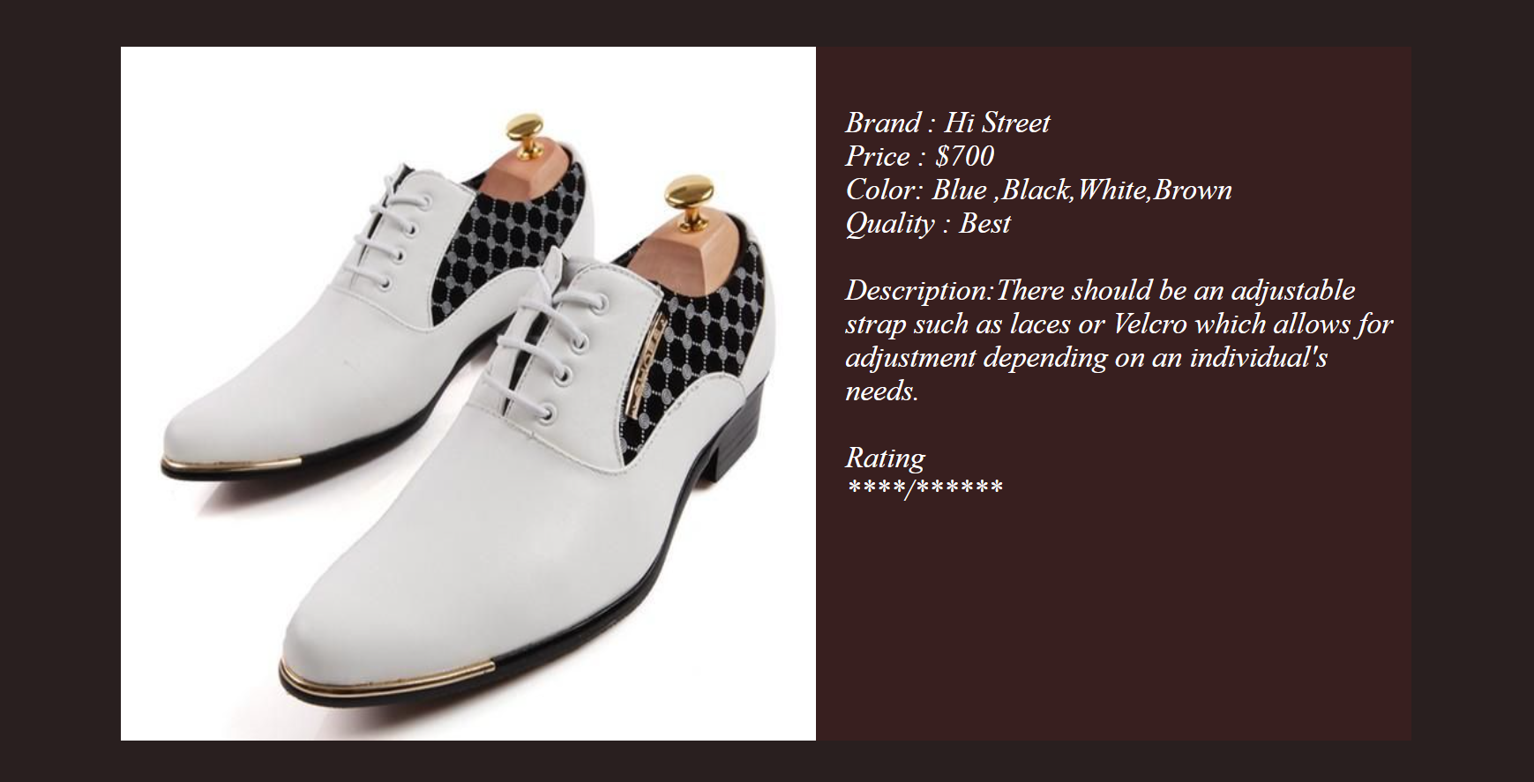

SOURCE CODE:

<!DOCTYPE html>

<html lang="en">

<head>

    <title>Document</title>

    <link rel="stylesheet" href="productpage1.html">

</head>

<body>

    <div style="background-color:rgb(41, 31, 31); height: 450px;width: 99%;">

    <div style="background-color: rgb(56, 31, 31); height: 350px;width: 650px;margin-left: 80px;margin-top: 50px;float: left;">

        <div style="background-color: rgb(253, 243, 243);height: 350px;width: 350px;float: left;">

        <img src="C:\Users\HP ELITEBOOK 840 G3\Desktop\web_engineering\pic9.jpg" style = "height: 350px; width: 350px;" >

        </div>

        <div style="background-color: rgb(56, 31, 31);height: 300px;width: 280px;float: left;color: white;font-size: 15px;font-family: 'Times New Roman', Times, serif;font-style: italic;padding-top: 30px;padding-left: 15px;">

        Brand : Hi Street<br>Price : $700<br>Color: Blue ,Black,White,Brown<br>Quality : Best<br><br>Description:There should be an adjustable strap such as laces or Velcro which allows for adjustment depending on an individual's needs.<br><br>Rating<br> ****/******

        </div>

    </div>

</div>

</body>

</html>

WEB PRODUCT PAGE

{INDIVIDUAL DESCRIPTION OF ITEM 2}

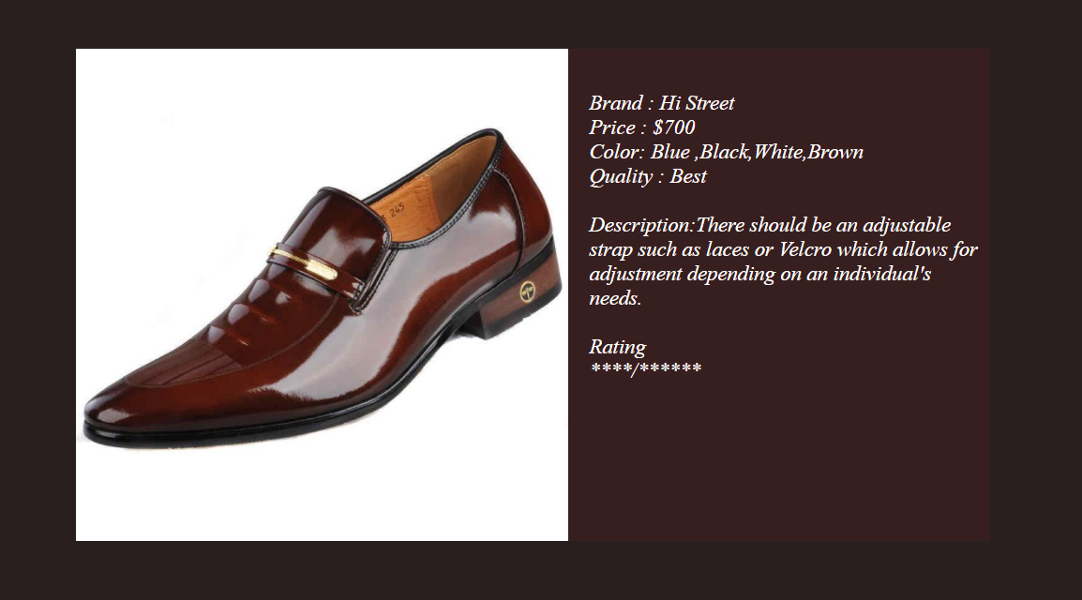

SOURCE CODE:

<!DOCTYPE html>

<html lang="en">

<head>

    <title>Document</title>

    <link rel="stylesheet" href="productpage1.html">

</head>

<body>

    <div style="background-color:rgb(41, 31, 31); height: 450px;width: 99%;">

    <div style="background-color: rgb(56, 31, 31); height: 350px;width: 650px;margin-left: 80px;margin-top: 50px;float: left;">

        <div style="background-color: rgb(253, 243, 243);height: 350px;width: 350px;float: left;">

        <img src="C:\Users\HP ELITEBOOK 840 G3\Desktop\web_engineering\pic8.jpEg" style = "height: 350px; width: 350px;" >

        </div>

        <div style="background-color: rgb(56, 31, 31);height: 320px;width: 280px;float: left;color: white;font-size: 15px;font-family: 'Times New Roman', Times, serif;font-style: italic;padding-top: 30px;padding-left: 15px;">

        Brand : Hi Street<br>Price : $700<br>Color: Blue ,Black,White,Brown<br>Quality : Best<br><br>Description:There should be an adjustable strap such as laces or Velcro which allows for adjustment depending on an individual's needs.<br><br>Rating<br> ****/******

        </div>

    </div>

</div>

</body>

</html>

WEB PRODUCT PAGE

{INDIVIDUAL DESCRIPTION OF ITEM 3}

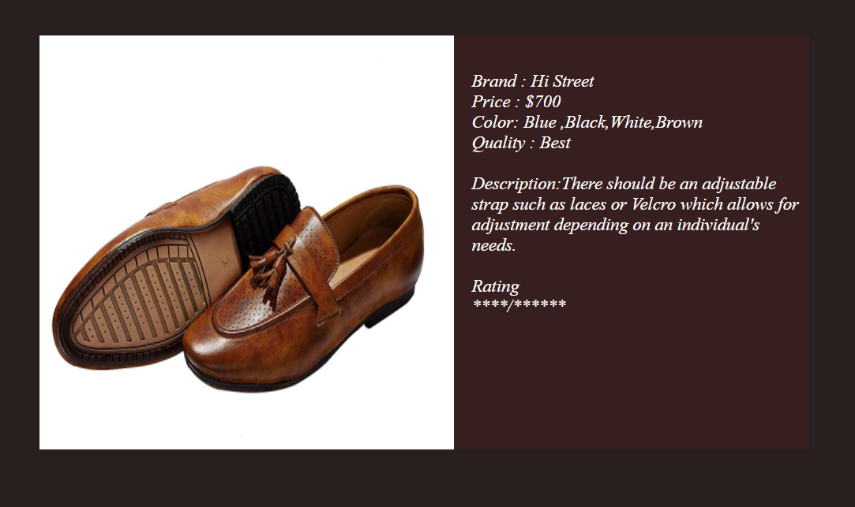

SOURCE CODE:

<!DOCTYPE html>

<html lang="en">

<head>

    <title>Document</title>

    <link rel="stylesheet" href="productpage1.html">

</head>

<body>

    <div style="background-color:rgb(41, 31, 31); height: 450px;width: 99%;">

    <div style="background-color: rgb(56, 31, 31); height: 350px;width: 650px;margin-left: 80px;margin-top: 50px;float: left;">

        <div style="background-color: rgb(253, 243, 243);height: 350px;width: 350px;float: left;">

        <img src="C:\Users\HP ELITEBOOK 840 G3\Desktop\web_engineering\pic12.jpg" style = "height: 350px; width: 350px;" >

        </div>

        <div style="background-color: rgb(56, 31, 31);height: 320px;width: 280px;float: left;color: white;font-size: 15px;font-family: 'Times New Roman', Times, serif;font-style: italic;padding-top: 30px;padding-left: 15px;">

        Brand : Hi Street<br>Price : $700<br>Color: Blue ,Black,White,Brown<br>Quality : Best<br><br>Description:There should be an adjustable strap such as laces or Velcro which allows for adjustment depending on an individual's needs.<br><br>Rating<br> ****/******

        </div>

    </div>

</div>

</body>

</html>

WEB PRODUCT PAGE

{INDIVIDUAL DESCRIPTION OF ITEM 4}

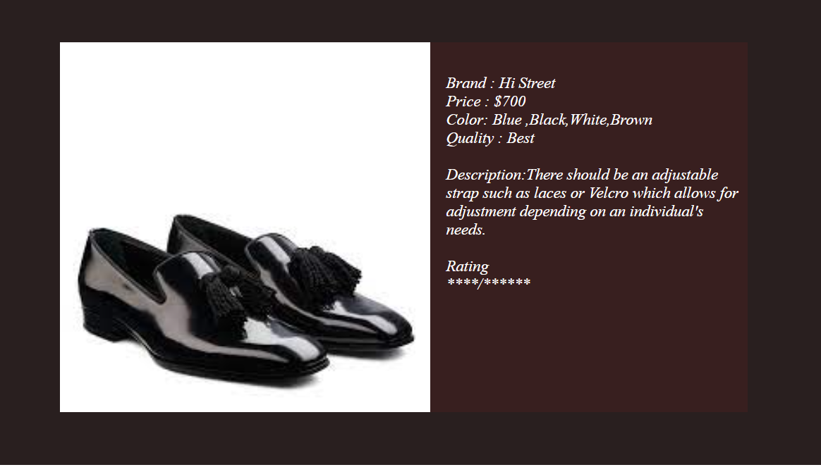

SOURCE CODE:

<!DOCTYPE html>

<html lang="en">

<head>

    <title>Document</title>

    <link rel="stylesheet" href="productpage1.html">

</head>

<body>

    <div style="background-color:rgb(41, 31, 31); height: 450px;width: 99%;">

    <div style="background-color: rgb(56, 31, 31); height: 350px;width: 650px;margin-left: 80px;margin-top: 50px;float: left;">

        <div style="background-color: rgb(253, 243, 243);height: 350px;width: 350px;float: left;">

        <img src="C:\Users\HP ELITEBOOK 840 G3\Desktop\web_engineering\pic5.jfif" style = "height: 350px; width: 350px;" >

        </div>

        <div style="background-color: rgb(56, 31, 31);height: 300px;width: 280px;float: left;color: white;font-size: 15px;font-family: 'Times New Roman', Times, serif;font-style: italic;padding-top: 30px;padding-left: 15px;">

        Brand : Hi Street<br>Price : $700<br>Color: Blue ,Black,White,Brown<br>Quality : Best<br><br>Description:There should be an adjustable strap such as laces or Velcro which allows for adjustment depending on an individual's needs.<br><br>Rating<br> ****/******

        </div>

    </div>

</div>

</body>

</html>

*************************************************************************************